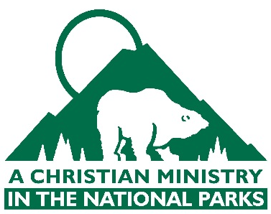

Advanced Leadership Development Program Application

If chosen to participate in ACMNP’s Advanced Leadership Development Program, you will be asked to embrace significant, faith-stretching challenges and responsibilities. As you respond to God’s leadership calling, you will help develop others and leave a lasting impact on the park communities for years to come. We will rely on you to lead where you land and leave a lasting mark on your park community and ACMNP Ministry Team in the name of Jesus Christ. If selected for ALDP, you will be required to attend the ALDP Training and National Training Conference in Estes Park, CO from April 15-19, 2020.

Please respond to the questions below with written responses that are 150 words or less.

- What leadership characteristics do you see in Jesus as revealed in the New Testament?

- Name another person (not Jesus) from the Bible, you think serves as a model of the kind of leader you would like to be. Describe the characteristics you think this person possesses and behaviors they practice that would be worth imitating?

- Write about a Scripture passage that reveals to you a Christian leadership principle.

- When you learned about ACMNP’s Advanced Leadership Development Program what intrigued you about the opportunity? (Brief answer, 50 words or less.)

- Describe a situation where you were called to lead others. As you look back on that experience, what would you do differently if given the opportunity?

- Describe the kind of Kingdom impact you would like to make during your life-time of service to God.

Applications are due by Sunday, March 1st to Carrie at cbruns@acmnp.com.

